J2ME Sample Game 18 – GUITest MIDlet

- Screenshots

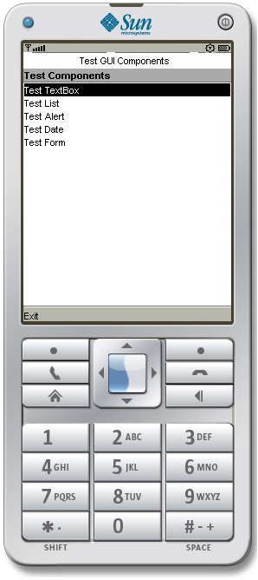
Figure 1 – Main Screen
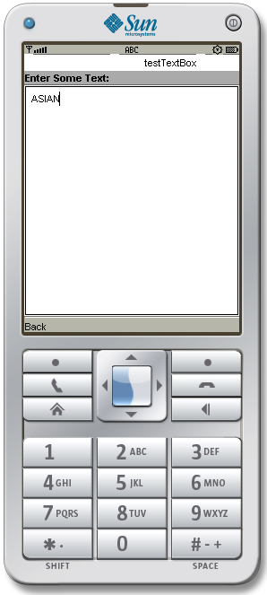
Figure 2 – Textbox Screen

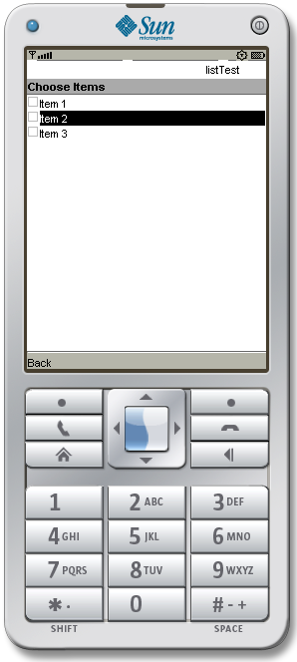
Figure 3 – ListItem Screen

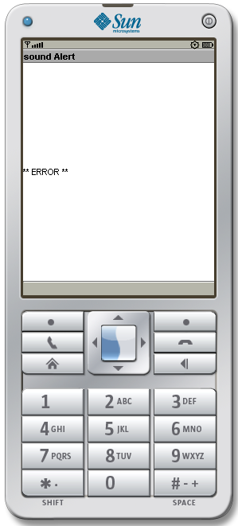
Figure 4 – Sound Alert Screen

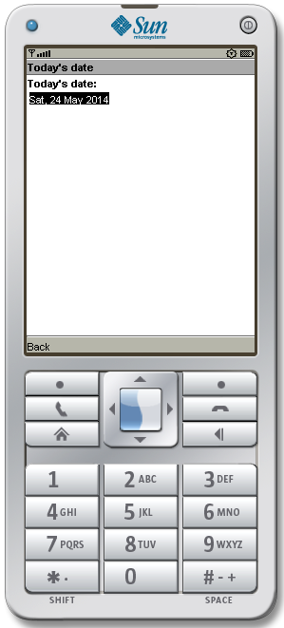
Figure 5 – Current Date Screen

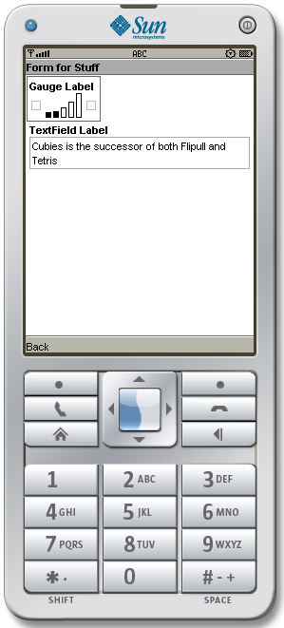
Figure 6 – Gauge and Textfield Screen

- Source Code

/*This example demonstrates how to create various GUI components.
The MIDlet for this example allows you to test lists, forms, choices,
gauges, text fields, text boxes, for example.*/

import javax.microedition.lcdui.*;
import javax.microedition.midlet.*;

public class GUITest extends MIDlet implements CommandListener
{
// display manager
Display display = null;

// a menu with items
List menu = null; // main menu

// list of choices
List choose = null;

// textbox
TextBox input = null;

// ticker
Ticker ticker = new Ticker("Test GUI Components");

// alerts
final Alert soundAlert = new Alert("sound Alert");

// date
DateField date = new DateField("Today's date: ", DateField.DATE);

// form
Form form = new Form("Form for Stuff");

// gauge
Gauge gauge = new Gauge("Gauge Label", true, 10, 0);

// text field
TextField textfield = new TextField("TextField Label", "abc", 50, 0);

// command
static final Command backCommand = new Command("Back", Command.BACK, 0);
static final Command mainMenuCommand = new Command("Main", Command.SCREEN, 1);
static final Command exitCommand = new Command("Exit", Command.STOP, 2);
String currentMenu = null;

// constructor.
public GUITest()
{
}

/**
* Start the MIDlet by creating a list of items and associating the
* exit command with it.
*/
public void startApp() throws MIDletStateChangeException
{
display = Display.getDisplay(this);
// open a db stock file

menu = new List("Test Components", Choice.IMPLICIT);
menu.append("Test TextBox", null);
menu.append("Test List", null);
menu.append("Test Alert", null);
menu.append("Test Date", null);
menu.append("Test Form", null);
menu.addCommand(exitCommand);
menu.setCommandListener(this);
menu.setTicker(ticker);

mainMenu();
}

public void pauseApp()
{
display = null;
choose = null;
menu = null;
ticker = null;
form = null;
input = null;
gauge = null;
textfield = null;
}

public void destroyApp(boolean unconditional)
{
notifyDestroyed();
}

// main menu
void mainMenu()
{
display.setCurrent(menu);
currentMenu = "Main";
}

/**
* Test the TextBox component.
*/
public void testTextBox()
{
System.out.println("textbox called");
input = new TextBox("Enter Some Text:", "", 5, TextField.ANY);
input.setTicker(new Ticker("testTextBox"));
input.addCommand(backCommand);
input.setCommandListener(this);
input.setString("");
display.setCurrent(input);
currentMenu = "input";
}

/**
* Test the List component.
*/
public void testList()
{
choose = new List("Choose Items", Choice.MULTIPLE);
choose.setTicker(new Ticker("listTest"));
choose.addCommand(backCommand);
choose.setCommandListener(this);
choose.append("Item 1", null);
choose.append("Item 2", null);
choose.append("Item 3", null);
display.setCurrent(choose);
currentMenu = "list";
}

/**
* Test the Alert component.
*/
public void testAlert()
{
soundAlert.setType(AlertType.ERROR);
soundAlert.setString("** ERROR **");
display.setCurrent(soundAlert);
}

/**
* Test the DateField component.
*/
public void testDate()
{
java.util.Date now = new java.util.Date();
date.setDate(now);
Form f = new Form("Today's date");
f.append(date);
f.addCommand(backCommand);
f.setCommandListener(this);
display.setCurrent(f);
currentMenu = "date";
}

/**
* Test the Form component.
*/
public void testForm()
{
form.append(gauge);
form.append(textfield);
form.addCommand(backCommand);
form.setCommandListener(this);
display.setCurrent(form);
currentMenu = "form";
}

/**
* Handle events.
*/
public void commandAction(Command c, Displayable d)
{
String label = c.getLabel();
if (label.equals("Exit"))
{
destroyApp(true);
}
else if (label.equals("Back"))
{
if(currentMenu.equals("list") || currentMenu.equals("input") ||
currentMenu.equals("date") || currentMenu.equals("form"))
{
// go back to menu
mainMenu();
}
}
else
{
List down = (List)display.getCurrent();
switch(down.getSelectedIndex())
{
case 0: testTextBox();break;
case 1: testList();break;
case 2: testAlert();break;
case 3: testDate();break;
case 4: testForm();break;
}
}
}
}

